|  |  |
| --- | --- |
| section ii - HYPERALIMENTATION  Contents |  |

200.000 HYPERALIMENTATION GENERAL INFORMATION

201.000 Introduction

202.000 Arkansas Medicaid Participation Requirements for Hyperalimentation Providers

202.100 Hyperalimentation Providers in Arkansas and Bordering States

202.200 Hyperalimentation Providers Enrollment in States Not Bordering Arkansas

202.300 Electronic Signatures

210.000 PROGRAM COVERAGE

211.000 Introduction

212.000 Scope

213.000 Coverage of Parenteral Hyperalimentation Services/Benefit Limits

214.000 Coverage of Enteral (Sole Source) Hyperalimentation Services/Benefit Limits

215.000 Exclusions

216.000 Documentation Requirements

216.100 Reserved

220.000 PRIOR AUTHORIZATION

221.000 Prior Authorization

222.000 Request for Prior Authorization

222.100 Approvals of Prior Authorization Requests

222.200 Denial of Prior Authorization Requests

222.300 Administrative Reconsideration and Appeals

222.400 Reserved

223.000 Pre-Approval of Hyperalimentation Services

230.000 REIMBURSEMENT

231.000 Method of Reimbursement

231.010 Fee Schedules

232.000 Rate Appeal Process

240.000 BILLING PROCEDURES

241.000 Introduction to Billing

242.000 CMS-1500 Billing Procedures

242.100 Hyperalimentation Procedure Codes

242.110 Parenteral Hyperalimentation Services

242.120 Enteral (Sole Source) Formulae

242.140 Hyperalimentation Equipment and Supplies

242.141 Equipment and Supplies for Parenteral Nutrition Therapy

242.142 Equipment and Supplies for Enteral (Sole Source) Nutrition Therapy

242.143 Reimbursement for the Enteral (Sole Source) Nutrition Infusion Pump

242.144 Reimbursement for the Enteral (Sole Source) Feeding Pump Supply Kit

242.145 Equipment Repairs for the Enteral Nutrition Infusion Pump

242.200 National Place of Service (POS) Code

242.300 Billing Instructions – Paper Only

242.310 Completion of CMS-1500 Claim Form

242.400 Special Billing Procedures

242.401 National Drug Codes (NDCs)

242.402 Billing of Multi-Use and Single-Use Vials

|  |  |
| --- | --- |
| 200.000 HYPERALIMENTATION GENERAL INFORMATION |  |
| 201.000 Introduction | 10-13-03 |

1. The following pages furnish detailed information regarding hyperalimentation services covered by Arkansas Medicaid. Both parenteral and enteral (sole source) nutrition therapy services are covered under the Arkansas Medicaid Hyperalimentation Program. In general, the term “hyperalimentation,” when referenced in this provider manual, refers to both parenteral and enteral (sole source) nutrition therapy.

|  |  |
| --- | --- |
| 202.000 Arkansas Medicaid Participation Requirements for Hyperalimentation Providers | 11-1-09 |

1. Parenteral and enteral (sole source) nutrition therapy services providers must meet the Provider Participation and enrollment requirements contained within Section 140.000 of this manual as well as the following criteria to be eligible for participation in the Arkansas Medicaid Program:
2. The provider of parental nutrition must be licensed as a retail pharmacy by the Arkansas State Board of Pharmacy. A copy of the provider’s current Arkansas Retail Pharmacy Permit must accompany the provider application and Medicaid contract.
3. Providers of both parenteral and enteral nutrition must be enrolled in the Title XVIII (Medicare) Program to provide hyperalimentation services. A copy of the Medicare letter of verification must accompany the application.

|  |  |
| --- | --- |
| 202.100 Hyperalimentation Providers in Arkansas and Bordering States | 9-1-14 |

Hyperalimentation providers in Arkansas and the six bordering states (Louisiana, Mississippi, Missouri, Oklahoma, Tennessee and Texas) will be enrolled as routine services providers if they meet all Arkansas Medicaid participation requirements outlined above.

Routine Services Provider

A. Enrollment in the program as a regular provider of routine services.

B. Reimbursement will be available for all services covered in the Arkansas Medicaid Program.

C. Claims must be filed according to the specifications in this manual. This includes assignment of ICD and HCPCS codes for all services rendered.

|  |  |
| --- | --- |
| 202.200 Hyperalimentation Providers Enrollment in States Not Bordering Arkansas | 3-1-11 |

A. Providers in states not bordering Arkansas may enroll in Arkansas Medicaid as limited services providers only after they have provided services to an Arkansas Medicaid eligible beneficiary and have a claim or claims to file.

To enroll, a non-bordering state provider must download an Arkansas Medicaid provider application and contract from the Arkansas Medicaid website and submit the application, contract and claim to Arkansas Medicaid Provider Enrollment. A provider number will be assigned upon approval of the provider application and the Medicaid contract. [View or print the provider enrollment and contract package (Application Packet).](https://humanservices.arkansas.gov/wp-content/uploads/ApplicationPacket.pdf) [View or print Provider Enrollment Unit Contact information.](https://humanservices.arkansas.gov/wp-content/uploads/ProviderEnrol.docx)

B. Limited services providers remain enrolled for one year.

1. 1. If a limited services provider provides services to another Arkansas Medicaid beneficiary during the year of enrollment and bills Medicaid, the enrollment may continue for one year past the most recent claim’s last date of service, if the enrollment file is kept current.
2. 2. During the enrollment period, the provider may file any subsequent claims directly to the Medicaid fiscal agent.
3. 3. Limited services providers are strongly encouraged to file subsequent claims through the Arkansas Medicaid website because the front-end processing of web-based claims ensures prompt adjudication and facilitates reimbursement.

|  |  |
| --- | --- |
| 202.300 Electronic Signatures | 10-8-10 |

1. Medicaid will accept electronic signatures provided the electronic signatures comply with Arkansas Code § 25-31-103 et seq.

|  |  |
| --- | --- |
| 210.000 PROGRAM COVERAGE |  |
| 211.000 Introduction | 10-13-03 |

1. Medicaid is designed to assist eligible Medicaid beneficiaries in obtaining medical care within the guidelines specified in Section I of this manual. Fluids, equipment and supplies necessary for the administration of the fluids in the beneficiary’s home for parenteral and enteral (sole source) nutrition therapy are covered by Medicaid under the Hyperalimentation Program.

|  |  |
| --- | --- |
| 212.000 Scope | 6-7-10 |

1. Hyperalimentation services are provided to beneficiaries at their place of residence. “Place of residence” is defined as the beneficiary’s own dwelling, an apartment, a relative’s home or a boarding home. Hyperalimentation services in the beneficiary’s place of residence may be covered only when the therapy is determined to be medically necessary for the patient and is prescribed by a physician.
2. Hospitalization is required to initiate parenteral and enteral, sole source nutrition.
3. Enteral (sole source) nutrition therapy must meet the criteria listed above and be the sole source of nutrition in order to be covered by Medicaid.
4. The request for prior authorization for therapy must be submitted on the form DMS-2615. [View or print form DMS-2615 and instructions for completion.](https://humanservices.arkansas.gov/wp-content/uploads/DMS-2615.docx) The prescribing physician must document the beneficiary’s diagnosis and brief medical history that supports the medical necessity of the requested nutritional therapy services. The prescription must specify the frequency, the route, the product name, volume and duration of the requested nutritional therapy.
5. Documentation describing the beneficiary’s or caregiver’s training in catheter care; solution preparation and infusion technique to ensure the prescribed therapy can be provided safely and effectively in the beneficiary’s place of residence must be available upon request. Hospital records documenting the initiation of parenteral or enteral sole source nutrition must be submitted with the initial prior authorization request for these services.
6. The Arkansas Medicaid Program does not cover enteral (sole source) nutrition therapy hyperalimentation services for patients residing in a long term care facility. Enteral (sole source) nutrition therapy services are included in the per diem amount paid to long term care facilities. Arkansas Medicaid does cover parenteral nutrition therapy services through the Hyperalimentation Program for long term care facility residents.

|  |  |
| --- | --- |
| 213.000 Coverage of Parenteral Hyperalimentation Services/Benefit Limits | 10-1-06 |

1. Daily parenteral nutrition is considered medically necessary for a patient with severe pathology of the alimentary tract that does not allow absorption of sufficient nutrients to maintain weight and strength commensurate with the patient’s general condition.
2. Hyperalimentation is delivery of nutrients through a central venous line. **Hyperalimentation is not a covered service when delivered through a peripheral IV.**

Coverage of parenteral nutrition therapy must be prior approved. Each request will be reviewed on a case by case basis. Some medical conditions that frequently cause severe nutritional deficiency, in spite of adequate oral intake, and result in the use of parenteral nutrition are:

A. Short bowel syndrome

B. Intestinal obstruction

C. Inflammatory bowel disease including ulcerative colitis and Crohn’s disease

D. Motility disorder (pseudo obstruction)

E. Radiation enteritis

F. Mesenteric infarction

G. Massive bowel resection

1. Parenteral hyperalimentation services include the provision and delivery of the prescribed therapy, equipment and supplies necessary for the administration of the parenteral nutrition in the beneficiary’s place of residence.
2. **A nutritional assessment performed by the hyperalimentation provider is not a covered service.**
3. Parenteral hyperalimentation services are limited to six units of service per day. A half-liter of the prescribed hyperalimentation total parenteral nutrition (TPN) equals one unit of service. Units may not be rounded up. Providers must bill a date span according to the prescribed daily volume. (Refer to Section 240.000 for billing instructions)

|  |  |
| --- | --- |
| 214.000 Coverage of Enteral (Sole Source) Hyperalimentation Services/Benefit Limits | 10-1-06 |

1. Coverage of sole source enteral therapy must be prior approved. Enteral (sole source) nutrition is considered medically necessary for a patient with a functioning gastrointestinal tract who cannot maintain weight and strength commensurate with his or her general condition due to pathology or non-function of the structures that normally permit food to reach the digestive tract. Enteral (sole source) therapy may be given by nasogastric, jejunostomy or gastrostomy tubes.
2. Coverage of enteral (sole source) nutrition therapy must be prior approved. Each request will be reviewed on a case by case basis. Typical examples of conditions that would qualify for coverage are:

A. Acute ulcerative colitis

B. Gastrointestinal cancer

C. Granulomatous colitis

D. Intestinal atresia (infants)

E. Ischemic bowel disease

F. Malabsorption syndrome

G. Short-gut syndrome

H. Head and neck cancer with reconstructive surgery

I. Central nervous system disease leading to interference with the neuromuscular mechanisms of ingestion of such severity that the patient cannot be maintained with oral feeding.

1. Enteral (sole source) hyperalimentation services include the provision and delivery of the prescribed therapy, equipment and supplies necessary for the administration of the prescribed therapy in the beneficiary’s place of residence.
2. Enteral (sole source) hyperalimentation services are limited to 30 units of service per day. One unit of service equals 100 calories of covered nutritional therapy product resulting in a maximum of 3000 calories per day. Units may not be rounded up. Providers must bill a date span according to the prescribed daily volume. (Refer to Section 240.000 for billing instructions.)

|  |  |
| --- | --- |
| 215.000 Exclusions | 10-1-06 |

1. Hyperalimentation equipment and supplies will not be authorized for use by a beneficiary in an institution not defined as the place of residence (See Section 212.000).
2. The WIC (Women Infants Children) Program must be accessed first for individuals aged 0 to five (5) years.
3. Nutritional supplementation is not covered under the Hyperalimentation Program.

|  |  |
| --- | --- |
| 216.000 Documentation Requirements | 11-1-09 |

1. The hyperalimentation provider must keep and maintain written records, inclusive of all documentation submitted requesting prior authorization. See Section 141.000 for general records that must be included in the provider’s files and Section 212.000 for records regarding prior authorization.
2. The hyperalimentation provider must establish and maintain written documentation in each beneficiary’s case file to support the medical necessity of each provided service. The beneficiary’s medical record, maintained by the provider, must include documentation from the beneficiary’s hospitalization which supports the medical necessity of the prescribed parenteral or enteral nutrition therapy.
3. All entries in a beneficiary’s case file must be signed and dated by the individual providing the service to include the person’s full name and credentials.
4. Other documentation in a beneficiary’s case file must include:

A. The beneficiary’s name and Medicaid identification number

B. The specific service provided

C. The date services are provided

D. Updated progress notes describing the nature and extent of specific services provided

E. All documentation submitted requesting prior authorization from DMS. (See Section 212.000 for documentation requirements.)

|  |  |
| --- | --- |
| 216.100 Reserved | 11-1--09 |

|  |  |
| --- | --- |
| 220.000 PRIOR AUTHORIZATION |  |
| 221.000 Prior Authorization | 8-1-21 |

1. Hyperalimentation fluids, equipment and supplies must be prior authorized by the Department of Human Services (DHS) or its designated vendor. [View or print contact information to obtain the DHS or its designated vendor step-by-step process for requesting prior authorization.](https://humanservices.arkansas.gov/wp-content/uploads/AFMC.docx)

|  |  |
| --- | --- |
| 222.000 Request for Prior Authorization | 8-1-21 |

1. Requests for prior authorization originate with the provider. The provider is responsible for obtaining the required medical information and necessary prescription information needed for completion of the Request for Prior Authorization and Prescription Form. [View or print form DMS-2615 and instructions for completion](https://humanservices.arkansas.gov/wp-content/uploads/DMS-2615.docx). This form must be signed and dated by the prescribing physician.
2. The request for prior authorization will be reviewed by the Department of Human Services (DHS) or its designated vendor. The documentation submitted with the prior authorization request must support the medical necessity of the requested nutritional therapy. In some cases, additional information may be requested (i.e., original prescription, records from the hospitalization initiating nutritional therapy, nutritional assessment to establish medical necessity for nutritional therapy, etc.).

|  |  |
| --- | --- |
| 222.100 Approvals of Prior Authorization Requests | 8-1-21 |

1. When the PA request is approved, a prior authorization control number will be assigned. Prior authorization approvals are authorized for a maximum of six (6) months (180 days) or for the life of the prescription, whichever is shorter. If the prescribing physician documents the beneficiary’s condition is chronic and unlikely to change, a prior approval may be authorized for a maximum of twelve (12) months. The effective date of the prior authorization will be the date the patient will begin therapy or the day following the last day of the previous authorization approval.

|  |  |
| --- | --- |
| 222.200 Denial of Prior Authorization Requests | 6-1-25 |

1. For a denied request, a letter containing case specific rationale that explains why the request was not approved will be mailed to the requesting provider and to the Medicaid beneficiary.

|  |  |
| --- | --- |
| 222.300 Administrative Reconsideration and Appeals | 6-1-25 |

A. Medicaid allows only one (1) reconsideration of an adverse decision. Reconsideration requests must be submitted in accordance with Section 160.000 of Section I of this Manual.

B. When the state Medicaid agency or its designee denies a reconsideration request or issues any adverse decision, the beneficiary may appeal and request a fair hearing. A request for a fair hearing must be submitted in accordance with Sections 160.000, 190.000, and 191.000 of Section I of this Manual.

|  |  |
| --- | --- |
| 222.400 Reserved | 6-1-25 |
| 223.000 Pre-Approval of Hyperalimentation Services | 8-1-21 |

1. When an eligible Medicaid beneficiary is discharged from the inpatient setting with the continuation of hyperalimentation services in the home, a provider may request a pre-approval for hyperalimentation before the anticipated discharge date. [View or print contact information to obtain the DHS or its designated vendor step-by-step process for requesting pre-approval for hyperalimentation.](https://humanservices.arkansas.gov/wp-content/uploads/AFMC.docx)
2. When approved, a prior authorization number will be assigned and will be effective for thirty (30) days. The provider must not bill for hyperalimentation services prior to the date of discharge or bill for services on the same dates of service as the inpatient stay.
3. If the beneficiary is not discharged within the thirty (30) days, the pre-approval will be void.
4. When continuation of the therapy is required past the initial thirty (30) day pre-approval, the provider must submit a recertification for prior authorization request with a prescription signed by the prescribing physician, prior to the end date of the pre-approval.
5. **A pre-approval of hyperalimentation services does not guarantee payment.**

|  |  |
| --- | --- |
| 230.000 REIMBURSEMENT |  |
| 231.000 Method of Reimbursement | 10-13-03 |

1. Reimbursement for hyperalimentation services is based on the amount billed not to exceed the Title XIX (Medicaid) maximum.

|  |  |
| --- | --- |
| 231.010 Fee Schedules | 12-1-12 |

1. Arkansas Medicaid provides fee schedules on the Arkansas Medicaid website. The fee schedule link is located at [https://medicaid.mmis.arkansas.gov](https://humanservices.arkansas.gov/divisions-shared-services/medical-services/helpful-information-for-providers/fee-schedules/) under the provider manual section. The fees represent the fee-for-service reimbursement methodology.
2. Fee schedules do not address coverage limitations or special instructions applied by Arkansas Medicaid before final payment is determined.
3. Procedure codes and/or fee schedules do not guarantee payment, coverage or amount allowed. Information may be changed or updated at any time to correct a discrepancy and/or error. Arkansas Medicaid always reimburses the lesser of the amount billed or the Medicaid maximum.

|  |  |
| --- | --- |
| 232.000 Rate Appeal Process | 10-13-03 |

1. A provider may request reconsideration of a Program decision by writing to the Assistant Director, Division of Medical Services. This request must be received within 20 calendar days following the application of policy and/or procedure or the notification of the provider of its rate. Upon receipt of the request for review, the Assistant Director will determine the need for a program/provider conference and will contact the provider to arrange a conference if needed. Regardless of the program decision, the provider will be afforded the opportunity for a conference, if he or she so wishes, for a full explanation of the factors involved and the Program decision. Following review of the matter, the Assistant Director will notify the provider of the action to be taken by the Division within 20 calendar days of receipt of the request for review or the date of the program/provider conference.
2. When the provider disagrees with the decision of the Assistant Director of the Division of Medical Services, the provider may appeal the question to a standing rate review panel established by the Director of the Division of Medical Services. The rate review panel will include one member of the Division of Medical Services, a representative of the provider association and a member of the Department of Human Services (DHS) management staff, who will serve as chairperson.
3. The request for review by the rate review panel must be postmarked within 15 calendar days following the notification of the initial decision by the Assistant Director, Division of Medical Services. The rate review panel will meet to consider the question(s) within 15 calendar days after receipt of a request for such appeal. The question(s) will be heard by the panel and a recommendation will be submitted to the Director of the Division of Medical Services.

|  |  |
| --- | --- |
| 240.000 BILLING PROCEDURES |  |
| 241.000 Introduction to Billing | 7-1-20 |

1. Hyperalimentation providers use the CMS-1500 form to bill the Arkansas Medicaid Program on paper for services provided to Medicaid beneficiaries. Each claim may contain charges for only one (1) beneficiary.
2. Section III of this manual contains information about available options for electronic claim submission.

|  |  |
| --- | --- |
| 242.000 CMS-1500 Billing Procedures |  |
| 242.100 Hyperalimentation Procedure Codes | 8-1-05 |

1. The following procedure codes must be used to bill for hyperalimentation services.
2. Formulas may not be purchased under the Prosthetics Program and the Hyperalimentation Program for the same beneficiary during the same period.

|  |  |
| --- | --- |
| 242.110 Parenteral Hyperalimentation Services | 2-1-22 |

1. One unit of service equals a half-liter of fluid and includes fluids and the equipment and supplies necessary for the administration of the fluids in the beneficiary’s place of residence.
2. [View or print the procedure codes for Hyperalimentation services.](https://humanservices.arkansas.gov/wp-content/uploads/HYPER_ProcCodes.xlsx)

|  |  |
| --- | --- |
| 242.120 Enteral (Sole Source) Formulae | 2-1-22 |

1. The following pages provide the enteral formula HCPCS procedure codes, any associated modifiers, code descriptions, and the formula covered for each HCPCS code. The code description lists the formula included in the category of nutrients.
2. Modifiers in this section are indicated by the headings M1, M2, and M3.
3. Enteral formulae are divided into several categories. Each unit of service equals one-hundred (100) calories of formula. All supplies and equipment necessary to administer the nutrients in the beneficiary’s place of residence, except the infusion pump and pump supply kit, are included in the unit description.
4. For beneficiaries from birth through four (4) years of age, the use of modifier **U8,** as well as additional documentation, will be required when a non-WIC formula is prescribed or WIC guidelines are not followed when prescribing special formula.
5. An EPSDT screening, which documents the PCP’s medical rationale for prescribing a formula, as well as medical records documenting the beneficiary’s failed trials of WIC formula, must be submitted for review. Flavor preference for formulae will not be considered for medical necessity.
6. A separate prior authorization must be obtained for the enteral infusion pump and the pump supply kit. The enteral infusion pump and the pump supply kit may be billed separately.
7. [View or print the procedure codes for Hyperalimentation services.](https://humanservices.arkansas.gov/wp-content/uploads/HYPER_ProcCodes.xlsx)
8. **Exceptions to Use of Formula**
9. The following exceptions must be followed in order to use formulae listed in this section.

A. Nutramigen LIPIL – Sensitivity or allergy to milk or soy protein; chronic diarrhea, food allergies, GI bleeds. Similac Advance must first have been tried.

B. Nutramigen Enflora LGG – Sensitivity or allergy to milk or soy protein; chronic diarrhea, food allergies, GI bleeds. Similac Advance must first have been tried.

C. Pregestimil – Allergy to milk or soy protein; chronic diarrhea, short gut; cystic fibrosis, fat malabsorption due to GI, or liver disease.

D. Gerber Extensive HA – Allergy to milk or soy protein; severe malnutrition; chronic diarrhea; short bowel syndrome, known or suspected corn allergy. Similac Advance must first have been tried.

E. Alfamino Junior – Allergy to cow’s milk, multiple food protein intolerance and food allergy associated conditions: short bowel syndrome, gastroesophageal reflux disease (GERD), eosinophilic esophagitis, malabsorption, and other GI disorders. Neocate Junior with Prebiotics is intended for children over the age of one (1) year.

F. Alfamino Infant – Allergy to cow’s milk, multiple food protein intolerance and food allergy associated conditions: short bowel syndrome, gastroesophageal reflux disease (GERD), eosinophilic esophagitis, malabsorption, and other GI disorders. Similac Expert Care Alimentum, Nutramigen or Pregestimil must first have been tried.

G. Portagen – Pancreatic insufficiency, bile acid deficiency, or lymphatic anomalies; biliary atresia; liver disease; chylothorax.

H. Similac PM 60/40 – Renal, cardiac, or other condition that requires lowered minerals.

I. Periflex Infant – PKU; Hyperphenylalaninemia; for infants and toddlers.

J. PKU Periflex Junior Plus – Hyperphenylalaninemia; for children and adults.

K. Gerber Good Start Premature 24 – Preterm, low birth weight. Not intended for feeding low birth weight infants after they reach a weight of 3600 g (approximately eight (8) lbs.). Not approved for an infant previously on term formula or a term infant for increased calories.

L. Enfamil EnfaCare – Preterm infant transitional formula for use between premature formula and term formula. Not approved for an infant previously on term formula or a term infant for increased calories.

NOTE: The Women, Infant, and Children program (WIC) must be accessed before the Medicaid Program for children from birth to five (5) years of age.

The Arkansas Medicaid program mirrors coverage of approved WIC nutritional formulae. As stated in current policy, the WIC Program must be accessed first for Arkansas Medicaid beneficiaries aged zero (0) to five (5) years, prior to requesting supplemental amounts of WIC-approved nutritional formula. The Medicaid nutritional formula list will be updated accordingly to continue compliance with the WIC program in Arkansas. Changes will be reflected in the appropriate Medicaid provider manual.

|  |  |
| --- | --- |
| **242.130 Pedia-Pop** | **2-1-22** |

1. The following procedure code must be utilized when billing for Pedia-Pop.
2. [View or print the procedure codes for Hyperalimentation services.](https://humanservices.arkansas.gov/wp-content/uploads/HYPER_ProcCodes.xlsx)
3. Reimbursement for this product is the provider’s cost plus ten percent (10%). Pedia-Pop is covered for eligible Medicaid beneficiaries of all ages. Pedia-Pop is only for oral consumption in frozen form and may not be appropriate for a hyperalimentation diet.

|  |  |
| --- | --- |
| 242.140 Hyperalimentation Equipment and Supplies |  |
| 242.141 Equipment and Supplies for Parenteral Nutrition Therapy | 9-1-05 |

1. Equipment and supplies necessary for the administration of parenteral nutrition therapy in the beneficiary’s place of residence are included in the unit reimbursement price. Equipment and supplies may not be billed separately for parenteral hyperalimentation. See Section 242.110.

|  |  |
| --- | --- |
| 242.142 Equipment and Supplies for Enteral (Sole Source) Nutrition Therapy | 2-1-22 |

1. Equipment and supplies necessary for the administration of enteral (sole source) nutrition therapy in the beneficiary’s place of residence are included in the unit reimbursement price. Prior authorization is required for the enteral infusion pump and the pump supply kit and may be billed separately. The prior authorization request for the pump must contain supporting documentation to establish medical necessity (e.g., gravity feeding is not satisfactory due to aspiration, diarrhea, dumping syndrome, etc.).
2. Prior authorization is indicated by the heading PA. If prior authorization is required, that information is indicated with a “Y” in the column; if not, an “N” is shown.
3. [View or print the procedure codes for Hyperalimentation services.](https://humanservices.arkansas.gov/wp-content/uploads/HYPER_ProcCodes.xlsx)

|  |  |
| --- | --- |
| 242.143 Reimbursement for the Enteral (Sole Source) Nutrition Infusion Pump | 2-1-22 |

1. Reimbursement for the enteral (sole source) nutrition infusion pump is based on a rent-to-purchase methodology. Each unit reimbursed by Medicaid will apply towards the purchase price established by Medicaid. Reimbursement will only be approved for new equipment. Used equipment will not be prior authorized.
2. [View or print the procedure codes for Hyperalimentation services.](https://humanservices.arkansas.gov/wp-content/uploads/HYPER_ProcCodes.xlsx)
3. Procedure codes each represent a new piece of equipment being reimbursed by Medicaid on the rent-to-purchase plan. Both codes are reimbursed on a per unit basis with 1 day equaling 1 unit of service.
4. The provider may bill for the infusion pump at a maximum of one (1) unit of service per day. Medicaid will reimburse on the rent-to-purchase plan for a total of 304 units of service. After reimbursement has been made for 304 units, the equipment will become the property of the Medicaid beneficiary.
5. Prior authorization is required for procedure codes. The prior authorization request must include the serial number of the infusion pump being provided to the beneficiary.

|  |  |
| --- | --- |
| 242.144 Reimbursement for the Enteral (Sole Source) Feeding Pump Supply Kit | 9-1-05 |

1. Reimbursement may be made for the pump supply kit necessary for the administration of the nutrients in the beneficiary’s place of residence when the feeding method involves an enteral nutrition infusion pump.
2. The pump supply kit and the infusion pump require prior authorization from the Utilization Review Section of the Division of Medical Services. The enteral feeding pump supply kit is reimbursed on a per unit basis with one (1) day equaling 1 unit of service. A maximum of 1 unit per day is allowed. The pump supply kit includes the pump sets, containers and syringes necessary for administration of the nutrients.
3. All other equipment and supplies are included in the unit price of the nutrient categories and may not be billed separately.

|  |  |
| --- | --- |
| 242.145 Equipment Repairs for the Enteral Nutrition Infusion Pump | 2-1-22 |

1. Reimbursement for repairs of the enteral nutrition infusion pump requires prior authorization. Repairs will be approved only on equipment purchased by Medicaid. Therefore, no repairs are covered before the equipment becomes the property of the Medicaid beneficiary.
2. Requests for prior authorization for enteral pump repairs must be mailed to the Utilization Review Section, Division of Medical Services as detailed in Section 220.000 of this manual. The repair invoice and the serial number of the equipment must accompany the prior authorization request form. Total repair costs to an infusion pump may not exceed $290.93.
3. Medicaid will not reimburse for additional repairs of an infusion pump after the provider has billed repair invoices totaling $290.93. If, after billing the Medicaid maximum allowed for repairs, the equipment is still not in proper working order, the provider must supply the beneficiary with a new infusion pump and may bill either procedure code after receiving prior authorization for the new piece of equipment.
4. To bill the Medicaid Program for repairs made to the enteral infusion pump, use the following procedure code.
5. [View or print the procedure codes for Hyperalimentation services.](https://humanservices.arkansas.gov/wp-content/uploads/HYPER_ProcCodes.xlsx)
6. ⁂(…) This symbol, along with text in parentheses, indicates the Arkansas Medicaid description of the product. When using a procedure code with this symbol, the product must meet the Arkansas Medicaid description.

|  |  |
| --- | --- |
| 242.200 National Place of Service (POS) Code | 7-1-07 |

1. The national place of service code is used for both electronic and paper billing.

| Place of Service | POS Code |
| --- | --- |
| Patient’s Home | 12 |

|  |  |
| --- | --- |
| 242.300 Billing Instructions – Paper Only | 11-1-17 |

1. Bill Medicaid for professional services with form CMS-1500. The numbered items in the following instructions correspond to the numbered fields on the claim form. [View a sample form CMS-1500.](https://humanservices.arkansas.gov/wp-content/uploads/SampleCMS-1500.pdf)
2. Carefully follow these instructions to help the Arkansas Medicaid fiscal agent efficiently process claims. Accuracy, completeness, and clarity are essential. Claims cannot be processed if necessary information is omitted.
3. Forward completed claim forms to the Claims Department. [View or print the Claims Department contact information.](https://humanservices.arkansas.gov/wp-content/uploads/Claims.docx)

NOTE: A provider delivering services without verifying beneficiary eligibility for each date of service does so at the risk of not being reimbursed for the services.

|  |  |
| --- | --- |
| 242.310 Completion of CMS-1500 Claim Form | 9-1-14 |

| Field Name and Number | Instructions for Completion |
| --- | --- |
| 1. (type of coverage) | Not required. |
| 1a. INSURED’S I.D. NUMBER (For Program in Item 1) | Beneficiary’s or participant’s 10-digit Medicaid or ARKids First-A or ARKids First-B identification number. |
| 2. PATIENT’S NAME (Last Name, First Name, Middle Initial) | Beneficiary’s or participant’s last name and first name. |
| 3. PATIENT’S BIRTH DATE | Beneficiary’s or participant’s date of birth as given on the individual’s Medicaid or ARKids First-A or ARKids First-B identification card. Format: MM/DD/YY. |
| SEX | Check M for male or F for female. |
| 4. INSURED’S NAME (Last Name, First Name, Middle Initial) | Required if insurance affects this claim. Insured’s last name, first name, and middle initial. |
| 5. PATIENT’S ADDRESS (No., Street) | Optional. Beneficiary’s or participant’s completemailing address (street address or post office box). |
| CITY | Name of the city in which the beneficiary or participant resides. |
| STATE | Two-letter postal code for the state in which the beneficiary or participant resides. |
| ZIP CODE | Five-digit zip code; nine digits for post office box. |
| TELEPHONE (Include Area Code) | The beneficiary’s or participant’s telephone number or the number of a reliable message/contact/ emergency telephone. |
| 6. PATIENT RELATIONSHIP TO INSURED | If insurance affects this claim, check the box indicating the patient’s relationship to the insured. |
| 7. INSURED’S ADDRESS (No., Street) | Required if insured’s address is different from the patient’s address. |
| CITY |  |
| STATE |  |
| ZIP CODE |  |
| TELEPHONE (Include Area Code) |  |
| 8. RESERVED | Reserved for NUCC use. |
| 1. 9. OTHER INSURED’S NAME (Last name, First Name, Middle Initial) | If patient has other insurance coverage as indicated in Field 11d, the other insured’s last name, first name, and middle initial. |
| a. OTHER INSURED’S POLICY OR GROUP NUMBER | Policy and/or group number of the insured individual. |
| b. RESERVED | Reserved for NUCC use. |
| SEX | Not required. |
| c. RESERVED | Reserved for NUCC use. |
| d. INSURANCE PLAN NAME OR PROGRAM NAME | Name of the insurance company. |
| 10. IS PATIENT’S CONDITION RELATED TO: |  |
| a. EMPLOYMENT? (Current or Previous) | Check YES or NO. |
| b. AUTO ACCIDENT? | Required when an auto accident is related to the services. Check YES or NO. |
| PLACE (State) | If 10b is YES, the two-letter postal abbreviation for the state in which the automobile accident took place. |
| c. OTHER ACCIDENT? | Required when an accident other than automobile is related to the services. Check YES or NO. |
| d. CLAIM CODES | The “Claim Codes” identify additional information about the beneficiary’s condition or the claim. When applicable, use the Claim Code to report appropriate claim codes as designated by the NUCC. When required to provide the subset of Condition Codes, enter the condition code in this field. The subset of approved Condition Codes is found at [www.nucc.org](http://www.nucc.org) under Code Sets. |
| 11. INSURED’S POLICY GROUP OR FECA NUMBER | Not required when Medicaid is the only payer. |
| a. INSURED’S DATE OF BIRTH | Not required. |
| SEX | Not required. |
| b. OTHER CLAIM ID NUMBER | Not required. |
| c. INSURANCE PLAN NAME OR PROGRAM NAME | Not required. |
| d. IS THERE ANOTHER HEALTH BENEFIT PLAN? | When private or other insurance may or will cover any of the services, check YES and complete items 9, 9a and 9d. Only one box can be marked. |
| 12. PATIENT’S OR AUTHORIZED PERSON’S SIGNATURE | Enter “Signature on File,” “SOF” or legal signature. |
| 13. INSURED’S OR AUTHORIZED PERSON’S SIGNATURE | Enter “Signature on File,” “SOF” or legal signature. |
| 14. DATE OF CURRENT:   1. ILLNESS (First symptom) OR INJURY (Accident) OR PREGNANCY (LMP) | Required when services furnished are related to an accident, whether the accident is recent or in the past. Date of the accident.  Enter the qualifier to the right of the vertical dotted line. Use Qualifier 431 Onset of Current Symptoms or Illness; 484 Last Menstrual Period. |
| 15. OTHER DATE | Enter another date related to the beneficiary’s condition or treatment. Enter the qualifier between the left-hand set of vertical, dotted lines.  The “Other Date” identifies additional date information about the beneficiary’s condition or treatment. Use qualifiers:  454 Initial Treatment  304 Latest Visit or Consultation  453 Acute Manifestation of a Chronic Condition  439 Accident  455 Last X-Ray  471 Prescription  090 Report Start (Assumed Care Date)  091 Report End (Relinquished Care Date)  444 First Visit or Consultation |
| 16. DATES PATIENT UNABLE TO WORK IN CURRENT OCCUPATION | Not required. |
| 17. NAME OF REFERRING PROVIDER OR OTHER SOURCE | Name and title of referral source, whether an individual (such as a PCP) or a clinic or other facility. |
| 17a. (blank) | Not required. |
| 17b. NPI | Enter NPI of the referring physician. |
| 18. HOSPITALIZATION DATES RELATED TO CURRENT SERVICES | When the serving/billing provider’s services charged on this claim are related to a beneficiary’s or participant’s inpatient hospitalization, enter the individual’s admission and discharge dates. Format: MM/DD/YY. |
| 19. ADDITIONAL CLAIM INFORMATION | Identifies additional information about the beneficiary’s condition or the claim. Enter the appropriate qualifiers describing the identifier. See [www.nucc.org](http://www.nucc.org) for qualifiers. | |
| 20. OUTSIDE LAB? | Not required. |
| 1. $ CHARGES | Not required. |
| 1. 21. DIAGNOSIS OR NATURE OF ILLNESS OR INJURY | Enter the applicable ICD indicator to identify which version of ICD codes is being reported.  Use “9” for ICD-9-CM.  Use “0” for ICD-10-CM.  Enter the indicator between the vertical, dotted lines in the upper right-hand portion of the field.  Diagnosis code for the primary medical condition for which services are being billed. Use the appropriate International Classification of Diseases (ICD). List no more than 12 diagnosis codes. Relate lines A-L to the lines of service in 24E by the letter of the line. Use the highest level of specificity. |
| 22. RESUBMISSION CODE | Reserved for future use. |
| ORIGINAL REF. NO. | Any data or other information listed in this field does not/will not adjust, void or otherwise modify any previous payment or denial of a claim. Claim payment adjustments, voids, and refunds must follow previously established processes in policy. |
| 23. PRIOR AUTHORIZATION NUMBER | The prior authorization or benefit extension control number if applicable. |
| 24A. DATE(S) OF SERVICE | The “from” and “to” dates of service for each billed service. Format: MM/DD/YY.  1. On a single claim detail (one charge on one line), bill only for services provided within a single calendar month.  2. Some providers may bill on the same claim detail for two or more sequential dates of service within the same calendar month when the provider furnished equal amounts of the service on each day of the date sequence. |
| B. PLACE OF SERVICE | Two-digit national standard place of service code. |
| C. EMG | Enter “Y” for “Yes” or leave blank if “No.” EMG identifies if the services was an emergency. |
| D. PROCEDURES, SERVICES, OR SUPPLIES |  |
| CPT/HCPCS | One CPT or HCPCS procedure code for each detail. |
| MODIFIER | Modifier(s) if applicable. |
| E. DIAGNOSIS POINTER | Enter the diagnosis code reference letter (pointer) as shown in Item Number 21 to relate to the date of service and the procedures performed to the primary diagnosis. When multiple services are performed, the primary reference letter for each service should be listed first; other applicable services should follow. The reference letter(s) should be A-L or multiple letters as applicable. The “Diagnosis Pointer” is the line letter from Item Number 21 that relates to the reason the service(s) was performed. |
| F. $ CHARGES | The full charge for the service(s) totaled in the detail. This charge must be the usual charge to any client, patient, or other recipient of the provider’s services. |
| G. DAYS OR UNITS | The units (in whole numbers) of service(s) provided during the period indicated in Field 24A of the detail. |
| H. EPSDT/Family Plan | Enter E if the services resulted from a Child Health Services (EPSDT) screening/referral. |
| I. ID QUAL | Not required. |
| J. RENDERING PROVIDER ID # | Enter the 9-digit Arkansas Medicaid provider ID number of the individual who furnished the services billed for in the detail or |
| NPI | Enter NPI of the individual who furnished the services billed for in the detail. |
| 25. FEDERAL TAX I.D. NUMBER | Not required. This information is carried in the provider’s Medicaid file. If it changes, please contact Provider Enrollment. |
| 26. PATIENT’S ACCOUNT NO. | Optional entry that may be used for accounting purposes; use up to 16 numeric or alphabetic characters. This number appears on the Remittance Advice as “MRN.” |
| 27. ACCEPT ASSIGNMENT? | Not required. Assignment is automatically accepted by the provider when billing Medicaid. |
| 28. TOTAL CHARGE | Total of Column 24F—the sum all charges on the claim. |
| 29. AMOUNT PAID | Enter the total of payments previously received on this claim. Do not include amounts previously paid by Medicaid. *Do **not** include in this total the automatically deducted Medicaid co-payments. |
| 30. RESERVED | Reserved for NUCC use. |
| 31. SIGNATURE OF PHYSICIAN OR SUPPLIER INCLUDING DEGREES OR CREDENTIALS | The provider or designated authorized individual must sign and date the claim certifying that the services were personally rendered by the provider or under the provider’s direction. “Provider’s signature” is defined as the provider’s actual signature, a rubber stamp of the provider’s signature, an automated signature, a typewritten signature, or the signature of an individual authorized by the provider rendering the service. The name of a clinic or group is not acceptable. |
| 32. SERVICE FACILITY LOCATION INFORMATION | If other than home or office, enter the name and street, city, state, and zip code of the facility where services were performed. |
| a. (blank) | Not required. |
| b. (blank) | Not required. |
| 33. BILLING PROVIDER INFO & PH # | Billing provider’s name and complete address. Telephone number is requested but not required. |
| a. (blank) | Enter NPI of the billing provider or |
| b. (blank) | Enter the 9-digit Arkansas Medicaid provider ID number of the billing provider. |

|  |  |
| --- | --- |
| 242.400 Special Billing Procedures | 10-13-03 |

1. Each claim should reflect a from and thru date of service. The claims should not be filed until the thru date has elapsed. Claims may be submitted on either a weekly or monthly basis.
2. Two separate claims should be filed when one prior authorization expires and another prior authorization begins.

|  |  |
| --- | --- |
| 242.401 National Drug Codes (NDCs) | 1-1-23 |

1. Effective for claims with dates of service on or after January 1, 2008, Arkansas Medicaid implemented billing protocol per the Federal Deficit Reduction Act of 2005. This explains policy and billing protocol for providers that submit claims for drug HCPCS/CPT codes with dates of service on and after January 1, 2008.
2. The Federal Deficit Reduction Act of 2005 mandates that Arkansas Medicaid require the submission of National Drug Codes (NDCs) on claims submitted with Healthcare Common Procedure Coding System, Level II/Current Procedural Terminology, 4th edition (HCPCS/CPT) codes for **drugs** administered. The purpose of this requirement is to assure that the State Medicaid Agencies obtain a rebate from those manufacturers who have signed a rebate agreement with the Centers for Medicare and Medicaid Services (CMS).

A. Covered Labelers

Arkansas Medicaid, by statute, will only pay for a drug procedure billed with an NDC when the pharmaceutical labeler of that drug is a covered labeler with Centers for Medicare and Medicaid Services (CMS). A “covered labeler” is a pharmaceutical manufacturer that has entered into a federal rebate agreement with CMS to provide each state a rebate for products reimbursed by Medicaid Programs. A covered labeler is identified by the first five (5) digits of the NDC. To assure a product is payable for administration to a Medicaid beneficiary, compare the labeler code (the first five (5) digits of the NDC) to the list of covered labelers which is maintained on the [DHS contracted Pharmacy vendor](https://ar.primetherapeutics.com/provider-documents) website.

A complete listing of **“Covered Labelers”** is located on the website. See Diagram 1 for an example of this screen. The effective date is when a manufacturer entered into a rebate agreement with CMS. The *Labeler termination date* indicates that the manufacturer no longer participates in the federal rebate program and therefore the products cannot be reimbursed by Arkansas Medicaid on or after the *termination date*.

*Diagram 1*

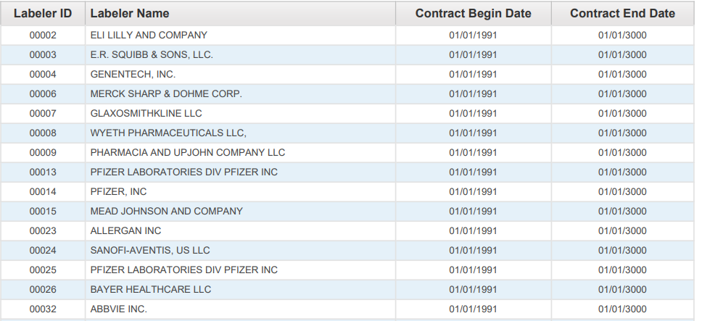

For a claim with drug HCPCS/CPT codes to be eligible for payment, the detail date of service must be prior to the *NDC termination date*. The NDC termination date represents the shelf-life expiration date of the last batch produced, as supplied on the Centers for Medicare and Medicaid Services (CMS) quarterly update. The date is supplied to CMS by the drug manufacturer/distributor.

Arkansas Medicaid will deny claim details with drug HCPCS/CPT codes with a detail date of service equal to or greater than the NDC termination date.

When completing a Medicaid claim for administering a drug, indicate the HIPAA standard 11-digit NDC with no dashes or spaces. The 11-digit NDC is comprised of three (3) segments or codes: a 5-digit labeler code, a 4-digit product code, and a 2-digit package code. The 10-digit NDC assigned by the FDA printed on the drug package must be changed to the 11-digit format by inserting a leading zero (0) in one (1) of the three (3) segments. Below are examples of the FDA assigned NDC on a package changed to the appropriate 11-digit HIPAA standard format. Diagram 2 displays the labeler code as five (5) digits with leading zeros; the product code as four (4) digits with leading zeros; the package code as two (2) digits without leading zeros, using the “5-4-2” format.

*Diagram 2*

|  |  |  |
| --- | --- | --- |
| **00123** | **0456** | **78** |
| **LABELER CODE**  **(5 digits)** | **PRODUCT CODE**  **(4 digits)** | **PACKAGE CODE**  **(2 digits)** |

NDCs submitted in any configuration other than the 11-digit format will be rejected/denied. NDCs billed to Medicaid for payment must use the 11-digit format without dashes or spaces between the numbers.

See Diagram 3 for sample NDCs as they might appear on drug packaging and the corresponding format which should be used for billing Arkansas Medicaid:

*Diagram 3*

|  |  |
| --- | --- |
| **10-digit FDA NDC on PACKAGE** | **Required 11-digit NDC**  **(5-4-2) Billing Format** |
| 12345 6789 1 | 123456789**0**1 |
| 1111-2222-33 | **0**1111222233 |
| 01111 456 71 | 01111**0**45671 |

B. Drug Procedure Code (HCPCS/CPT) to NDC Relationship and Billing Principles

HCPCS/CPT codes and any modifiers will continue to be billed per the policy for each procedure code. However, the NDC and NDC quantity of the administered drug is now also required for correct billing of drug HCPCS/CPT codes. To maintain the integrity of the drug rebate program, it is important that the specific NDC from the package used at the time of the procedure be recorded for billing. HCPCS/CPT codes submitted using invalid NDCs or NDCs that were unavailable on the date of service will be rejected/denied. We encourage you to enlist the cooperation of all staff members involved in drug administration to assure collection or notation of the NDC from the actual package used. It is not recommended that billing of NDCs be based on a reference list, as NDCs vary from one (1) labeler to another, from one (1) package size to another, and from one (1) time period to another.

Exception: There is no requirement for an NDC when billing for vaccines, radiopharmaceuticals, and allergen immunotherapy.

1. **I. Claims Filing**
2. The HCPCS/CPT codes billing units and the NDC quantity do not always have a one-to-one relationship.
3. Example 1: The HCPCS/CPT code may specify up to 75 mg of the drug whereas the NDC quantity is typically billed in units, milliliters or grams. If the patient is provided 2 oral tablets, one at 25 mg and one at 50 mg, the HCPCS/CPT code unit would be 1 (1 total of 75 mg) in the example whereas the NDC quantity would be 1 each (1 unit of the 25 mg tablet and 1 unit of the 50 mg tablet). See Diagram 4.
4. *Diagram 4*

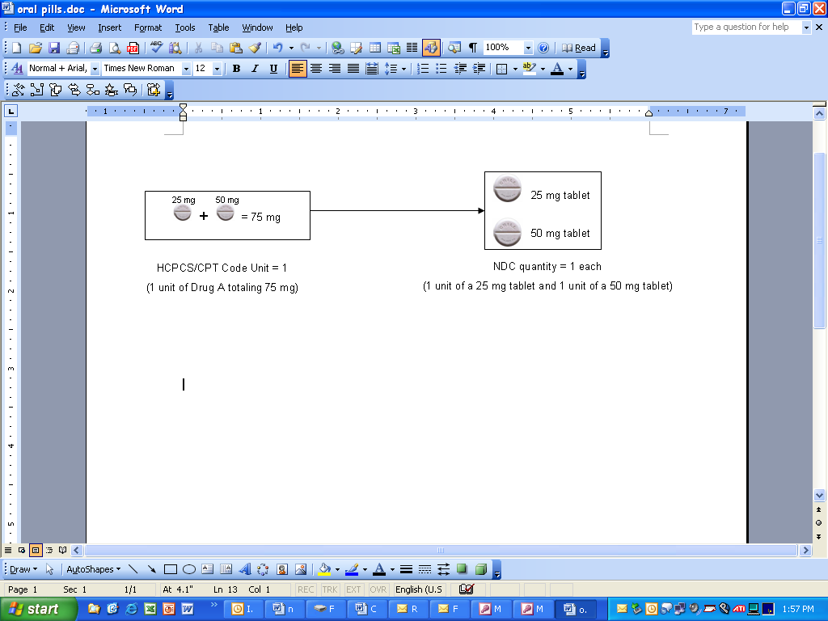

1. Example 2: If the drug in the example is an injection of 5 ml (or cc) of a product that was 50 mg per 10 ml of a 10 ml single-use vial, the HCPCS/CPT code unit would be 1 (1 unit of 25 mg) whereas the NDC quantity would be 5 (5 ml). In this example, 5 ml or 25 mg would be documented as wasted. See Diagram 5. For billing wastage, see bullets A (Electronic Claims Filing) and B (Paper Claims Filing) below.
2. *Diagram 5*

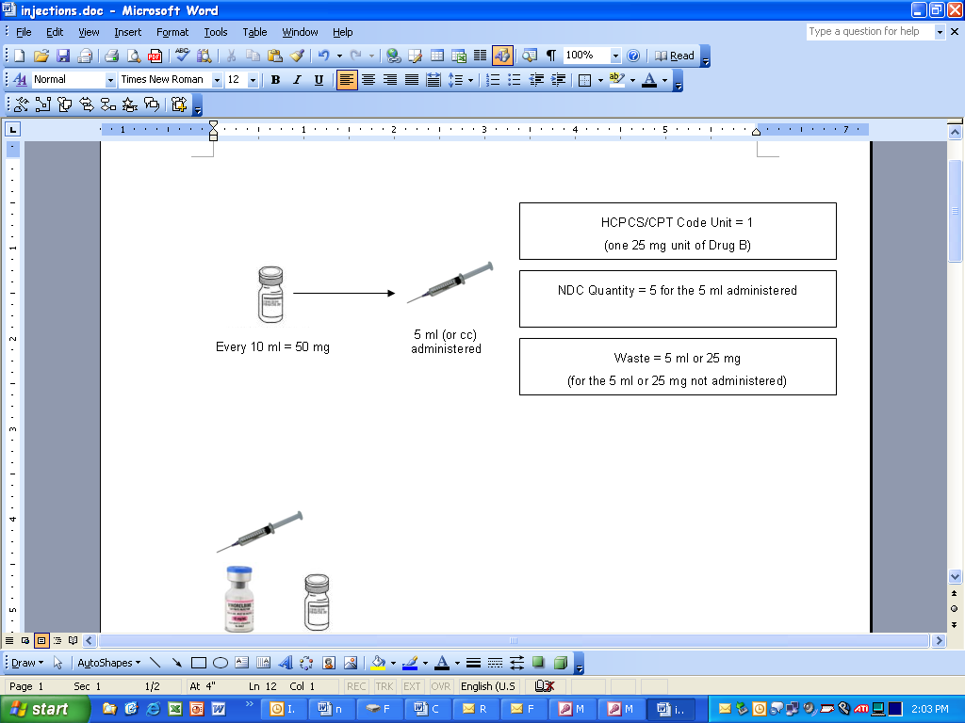

A. Electronic Claims Filing – 837P (Professional) and 837I (Outpatient)

1. Providers are instructed to bill as follows:

* 1 NDC for a procedure – 1st/only detail shall be billed with no modifier
* 2 NDCs for same procedure – 1st detail shall be billed with a KP and 2nd gets billed with a KQ modifier
* 3 NDCs for same procedure – 1st detail shall be billed with a KP and 2nd & 3rd detail get billed with a KQ modifier
* 4 or more NDCs for same procedure – submit via paper claim
* Wastage of each NDC shall be billed on a separate line with a JW modifier.

NOTE: The NDCs listed above are not the same (unless with a JW modifier). Same NDCs shall be billed on a single line with appropriate units.

**NOTE: CMS definitions of modifiers:**

* KP = First drug of a multiple drug unit dose formulation
* KQ = Second or subsequent drug of a multiple drug unit dose formulation
* JW = Drug wastage

B. Paper Claims Filing – CMS-1500

1. Providers are instructed to bill as follows:

* 1 NDC for a procedure – 1st/only detail shall be billed with no modifier
* 2 NDCs for same procedure – 1st detail shall be billed with a KP and 2nd gets billed with a KQ modifier
* 3 NDCs for same procedure – 1st detail shall be billed with a KP and 2nd & 3rd detail get billed with a KQ modifier
* 4 or more NDCs for same procedure – 1st detail shall be billed with a KP and 2nd and subsequent details shall be billed with a KQ modifier
* Wastage of each NDC shall be billed on a separate line with a JW modifier.

**NOTE: CMS definitions of modifiers:**

* KP = First drug of a multiple drug unit dose formulation
* KQ = Second or subsequent drug of a multiple drug unit dose formulation
* JW = Drug wastage

*Diagram 6*

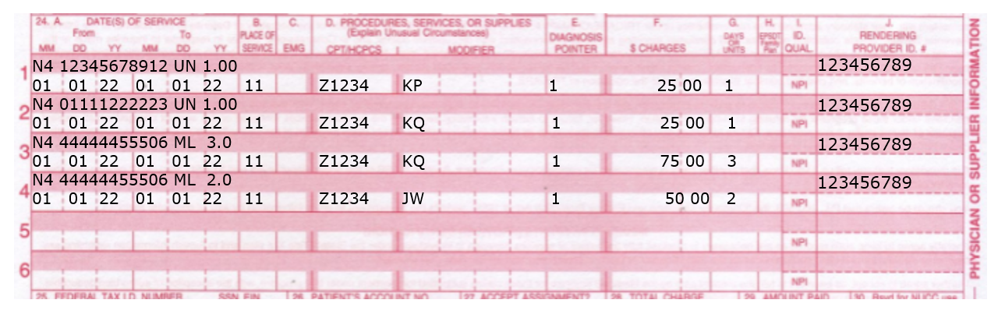

1. **II. Adjustments**
2. Paper adjustments for paid claims filed with NDC numbers will not be accepted. Any original claim will have to be voided and a replacement claim will need to be filed. Providers have the option of adjusting a paper or electronic claim electronically.
3. **III. Record Retention**
4. Each provider must retain all records for five (5) years from the date of service or until all audit questions, dispute or review issues, appeal hearings, investigations or administrative/judicial litigation to which the records may relate are concluded, whichever period is longer.
5. At times, a manufacturer may question the invoiced amount, which results in a drug rebate dispute. If this occurs, you may be contacted requesting a copy of your office records to include documentation pertaining to the billed HCPCS/CPT code. Requested records may include NDC invoices showing purchase of drugs and documentation showing what drug (name, strength and amount) was administered and on what date, to the beneficiary in question.

|  |  |
| --- | --- |
| 242.402 Billing of Multi-Use and Single-Use Vials | 1-1-23 |

1. Arkansas Medicaid follows the billing protocol per the Federal Deficit Reduction Act of 2005 for drugs.

A. Multiple units may be billed when applicable. Take-home drugs are not covered. Drugs loaded into an infusion pump are not classified as “take-home drugs.” Refer to payable CPT code ranges.

1. [View or print the procedure codes for Hyperalimentation services.](https://humanservices.arkansas.gov/wp-content/uploads/HYPER_ProcCodes.xlsx)

B. When submitting Arkansas Medicaid drug claims, drug units should be reported in multiples of the dosage included in the HCPCS procedure code description. If the dosage given is not a multiple of the number provided in the HCPCS code description the provider shall round up to the nearest whole number in order to express the HCPCS description number as a multiple.

1. 1. **Single-Use Vials:** If the provider must discard the remainder of a **single-use vial** or other package after administering the prescribed dosage of any given drug, Arkansas Medicaid will cover the amount of the drug discarded along with the amount administered. Discarded drugs shall be billed on a separate detail line with a JW (Drug wastage) modifier.
2. 2. **Multi-Use Vials**: Multi-use vials are not subject to payment for any discarded amounts of the drug. The units billed must correspond with the units administered to the beneficiary.
3. 3. **Documentation:** The provider must clearly document in the patient’s medical record the actual dose administered in addition to the exact amount wasted and the total amount the vial is labeled to contain.
4. Remember to verify the milligrams given to the patient and then convert to the proper units for billing.
5. Follow the Centers for Disease Control (CDC) requirements for safe practices regarding expiration and sterility of multi-use vials.