TO: Arkansas Medicaid Health Care Providers – Certified Nurse-Midwife

EFFECTIVE DATE: July 1, 2025

SUBJECT: Provider Manual Update Transmittal CNM-1-25

|  |  |  |  |
| --- | --- | --- | --- |
| **REMOVE** | | **INSERT** | |
| **Section** | **Effective Date** | **Section** | **Effective Date** |
| 215.260 | 1-1-23 | 215.260 | 7-1-25 |

Explanation of Updates

Section 215.260 is updated to include Presumptive Eligibility Pregnant Women (Category 62), including restricted prenatal services and services for conditions that may complicate the pregnancy.

This update transmittal memorandum indicates which sections of your provider manual have been revised. Electronic versions of provider manuals available from the Arkansas Medicaid website have changes incorporated. See Section I for instructions on updating a paper copy of the manual.

If you have questions regarding this transmittal, please contact the Provider Assistance Center at  
(800) 457-4454 toll-free or locally at (501) 376-2211.

If you need this material in an alternative format, such as large print, please contact the Office of Policy and Rules at (501) 320-6428.

Arkansas Medicaid provider manuals (including update transmittals), official notices, notices of rule making, and remittance advice (RA) messages are available for downloading from the [Division of Medical Services website](https://humanservices.arkansas.gov/divisions-shared-services/medical-services/helpful-information-for-providers/manuals/).

Thank you for your participation in the Arkansas Medicaid Program.

Elizabeth Pitman

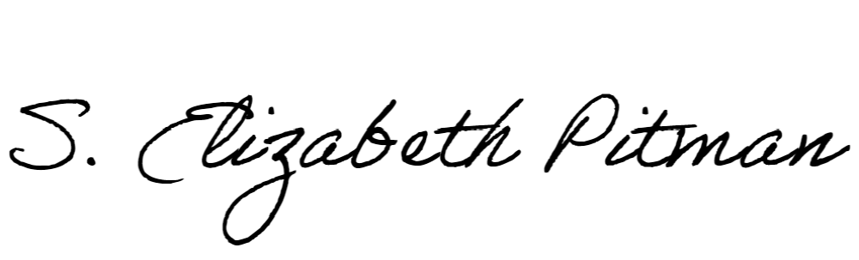

Director