Program | Report Name | Brief Description | Report Format | Audience (Users) | Update Frequency | Delivery Mechanism
PCMH | Population Health Monthly Report (PHMR) | PCMH report generated each month that provides summary and beneficiary metric level data to assist the provider community in proactively managing their patient population. This report summarizes provider performance across their attributed patient population, regardless of where patients receive care, and focuses on key metrics for preventative care, medication therapy management, chronic disease management, and utilization of high-cost services. | XSLX | - DHS  - PCMH Enrolled Providers  - DHS authorized vendors | Monthly (15th of each month) | PCMH Portal Report Center
PCMH | Population Health Monthly Report (PHMR)- Vaccine Report | PCMH report generated each month that provides summary and beneficiary-level vaccination status data for 0-2- and 4–6-year-old. This report incorporates data from the State of Arkansas Vaccination Registry. | XSLX | - DHS  - PCMH Enrolled Providers  - DHS authorized vendors | Monthly (15th of each month) | PCMH Portal Report Center
PCMH | PCMH Provider Report | Quarterly progress report providing a PCMH-level update toward meeting program requirements, including:  - PCMH attribution requirements  - Practice support activity status  - Metric rates for quality, core, PBIP, and informational metrics  - Care category cost breakdown | PDF | - DHS  - PCMH Enrolled Providers  - DHS authorized vendors | Quarterly | PCMH Portal Report Center
PCMH | PCMH Shared Savings Report | Quarterly progress report providing a Shared Entity-level update toward meeting program requirements, including:  - Pool attribution requirements  - Metric rates for quality, PBIP, and informational metrics  - Care category cost breakdown | PDF | - DHS  - PCMH Enrolled Providers  - DHS authorized vendors | Quarterly  (Retired after the 2020 PCMH enrollment) | PCMH Portal Report Center
PCMH | Narcotic Profile Report | Informational report for chronic narcotic use among attributed beneficiaries based on prescriptions written by any provider within the PCMH or by any provider. Rates are provided for medication categories of opioids, benzodiazepines, non-benzodiazepine sleeping aids along with all medication categories including polypharmacy. | PDF | - DHS  - PCMH Enrolled Providers  - DHS authorized vendors | Bi-annual  (2nd & 4th quarter)  (Retired after Q4 2021) | PCMH Portal Report Center
PCMH | Oral Antibiotic Utilization Report | Informational report detailing oral antibiotic prescription utilization per 1,000 attributed beneficiaries, stratified by age group, gender, Arkansas region and county, and oral antibiotic drug class. | PDF | - DHS  - PCMH Enrolled Providers  - AFMC  - DHS authorized vendors | Bi-annual  (2nd & 4th quarter) | PCMH Portal Report Center
PCMH | Patient Panel Export | Displays the current practice patient panel per Quarter with current risk scores if they have achieved 6 months attributed and if counted in the HPB list or MDX | XSLX | - DHS  - PCMH Enrolled Providers  - DHS authorized vendors | The patient panel is updated quarterly, but the Patient Panel Selection monitoring data is updated real time as providers complete their selections. | Dashboard Excel Export**
PCMH | Practice Support Activities Attestation Export | Actual list of Practice Support Activities when they are due as well as a process for the providers to attest to these and download supporting documentation. | XSLX | - DHS  - PCMH Enrolled Providers  - DHS authorized vendors | Updated real time as providers complete attestation. | Dashboard Excel Export**
PCMH | High Priority Care Plan Validation Export | After selection of their HPB list the provider are able to download care plans to support their selection and to be validated. | XSLX | - DHS  - PCMH Enrolled Providers  - DHS authorized vendors | Updated real time as providers complete attestation and as AFMC completes validation. | Dashboard Excel Export**
PCMH | Performance Based Incentive Payment (PBIP) Reconciliation Export | This report recognizes every patient that is counted adversely in these three measures and allows the practice to submit supporting documentation for those they feel should be counted for them. It allows for the DMS to communicate with providers if they need additional information or if the incorrect information has been provided. It allows for DMS make a final decision on each patient of visit. | XSLX | - DHS  - PCMH Enrolled Providers  - DHS authorized vendors | Updated annually,  monitoring is updated real time. | Dashboard Excel Export**
PCMH | PCMH Metric Aggregation Report | Practice support, quality, and utilization metric aggregated results reported at the PCMH and Pool levels. | XSLX | - DMS  - DHS authorized vendors | Quarterly | Email: DHS, AFMC, analytics vendor  PCMH Report List: DHS, analytics vendor
PCMH | PCMH Dashboard | The PCMH Dashboard is intended to be used by DMS staff as a reference guide for important PCMH facts and data on enrolled and unenrolled practices. | XSLX | - DMS  - DHS authorized vendors | No longer updated. Last update was Q1 2020. | PCMH Report List: DHS, analytics vendor
PCMH | PCMH Performance Summary Report | The PCMH Performance Summary (PPS) Report is an internal evaluation of the PCMH program, intended to serve as an overall summary of and quick reference to key performance indicators. | PDF | - DMS  - DHS authorized vendors | Annual  (2nd quarter) | PCMH Report List: DHS, analytics vendor
PCMH | PCMH Attribution Report | Displays the PCPs attributed to the PCMH. | XSLX | - DMS  - DHS authorized vendors | Quarterly  (Retired after Q4 2021) | PCMH Report List: DHS, AFMC, analytics vendor
PCMH | PCMH Beneficiary Care Category Report | PCMH reports that provide detailed beneficiary and care category level data. | XSLX | - DMS  - DHS authorized vendors | Quarterly | PCMH Report List: DHS, analytics vendor
PCMH | PCMH Beneficiary Care Category Report (Excel Format) | PCMH reports that provide detailed beneficiary and care category level data. | XSLX | - PCMH Enrolled Providers | Quarterly | PCMH Portal (Report Center):  DMS, PCMH Providers
PCMH | PCMH Beneficiary Metric Dashboard | PCMH reports that provide detailed beneficiary and metric level data. | XSLX | - DMS  - DHS authorized vendors | Quarterly | PCMH Report List: DHS, analytics vendor
PCMH | PCMH Beneficiary Metric Dashboard (Excel Format) | PCMH reports that provide detailed beneficiary and metric level data. | XSLX | - PCMH Enrolled Providers | Quarterly | PCMH Portal (Report Center):  DHS, PCMH Providers
PCMH | Year-End Analysis | Year-end analysis is a presentation of PCMH’s preliminary and final performance overview. Cost analysis and graphics include controlling the cost of care represented as total cost of care, coordination payments to providers and net cost spending. Overview demonstrates risk-adjusted medical cost per capita compared to benchmark tend for practices enrolled and not enrolled in PCMH. Presentation provides the percentage of eligible beneficiaries, PCPs, and practices enrolled in 2014 compared to reported program year. Also, shows relative improvement between reporting program year and previous reporting program year for hospitalizations and emergency room visits as possible contributing factors to total cost of care. Metric graphics include relative percentage and absolute change in Quality and Core metrics between reporting program year and previous reporting program year and eCQM distributions. | PDF | - DMS  - DHS authorized vendors | Bi-annual  (1st & 3rd quarter) | Email:  DHS, analytics vendor
PCMH | Annual Metric Target Setting and Metric Selection | Metric target setting and metric selection is a presentation to recommend retired metrics, moved metrics and metric targets for new PCMH program year. Data analysis provides recommendations on which metrics should be modified for the next performance period. Historical comparison of targets is provided along with graphics representing delta to target on future and current metrics at the PCMH and Pool levels. Detailed metric distributions are included at the PCMH and Pool levels for non-Informational metrics. Also, includes metric descriptions, proposed updated logic on existing metrics and proposed new metrics. | XSLX | - DMS  DHS authorized vendors | Annual  (3rd quarter prior to new PCMH program year) | Email:  DHS, analytics vendor

**Note: Access to Exports/Dashboards is role based. Administrative organizations (DHS, DHS authorized vendors as approved) have access to all PCMH providers. PCMH organizations are limited to approved organizations only.
Patient Panel Export/Dashboard Mock-up
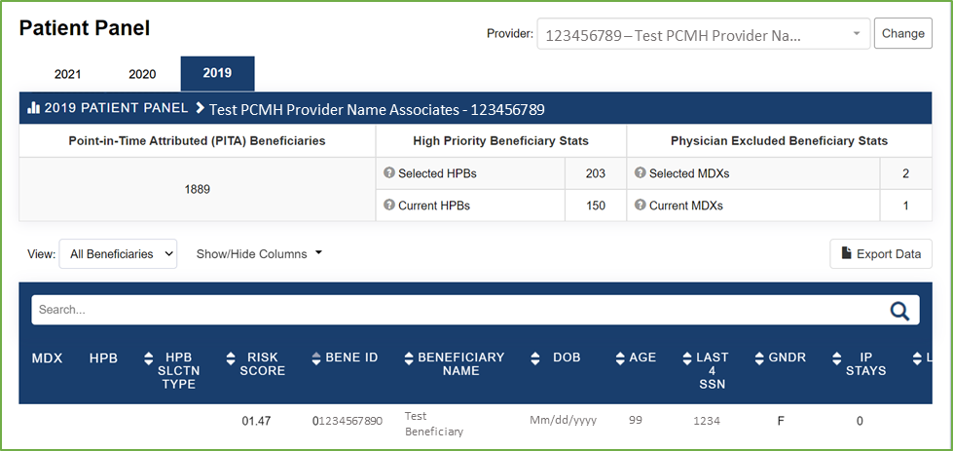

Practice Support Activities Attestation Export/Dashboard Mock-up
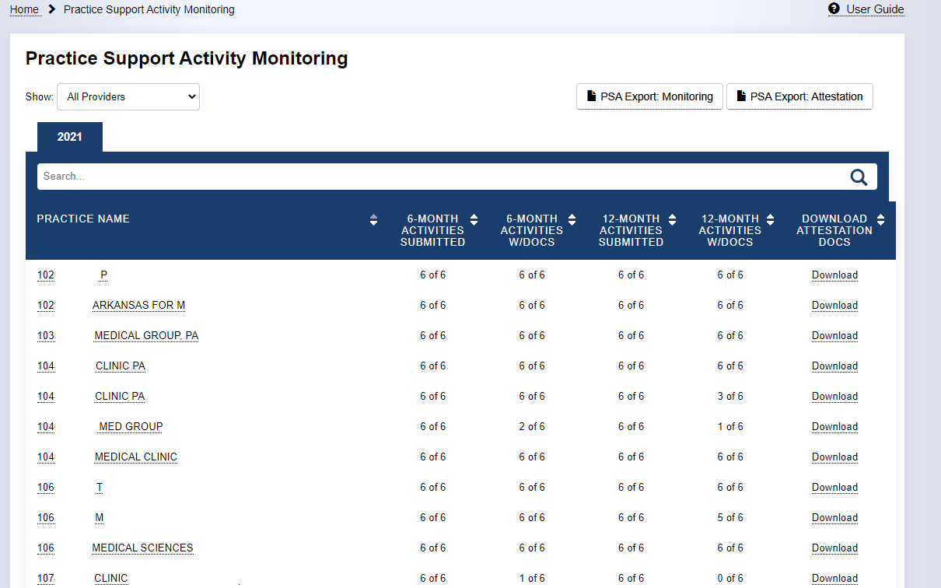
High Priority Care Plan Validation Export/Dashboard Mock-up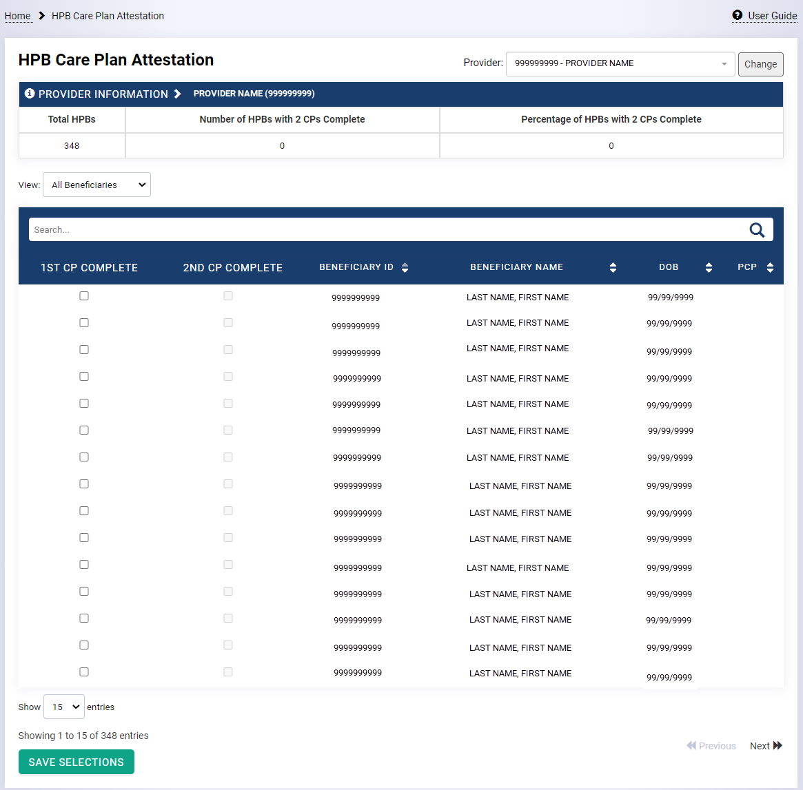

Performance Based Incentive Payment (PBIP) Reconciliation Export/Dashboard Mock-up
